Coderdojo Python Setup

Ft. pygame!

Step 1: Run this command in terminal to install pygame:

py -m pip install pygame

Step 2: install VSCode from this link:

https://code.visualstudio.com/

Step 3: unzip the code into a new folder, this will be our project folder

Step 4: Open that folder in vs code by clicking on file → open folder in vscode

Step 5: Click on gameloop.py in vscode and click the run button

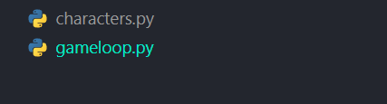Figure 1: Files view
Figure 2: Run button

Coderdojo Python challenges!

Challenge 1: in gameloop.py get the player to spawn

Hint 1: you will need to create a variable for him
Hint 2: use a function/method called “DrawPlayer()” to draw the player.

Challenge 2: use the function “movePlayer()” to move the player up using the “w” key.

Challenge 3: modify the function “movePlayer()” to move the player in the other directions:

Hint 1: “A“ - moves player left
Hint 2: “S” - moves player down
Hint 3: “D” - moves player right

INFO 1: Pygame’s (0,0) cordinate is the top left of the game window, so we rarely use minus coordinates for a static game like this, although it is usable!

INFO 2: a vector in pygame and maths contains two positions a:
“x” co-ordinate,
“y” co-ordinate,
in a 2d plane like below, in this case x is for left and right, y is for up and down.

